Tenda F3--How to Setup Universal Repeater

Step 1: Login the homepage.

- Open a browser then type “192.168.0.1” into the Address Bar, press Enter. Then enter the password of this page. Tap “Login”.

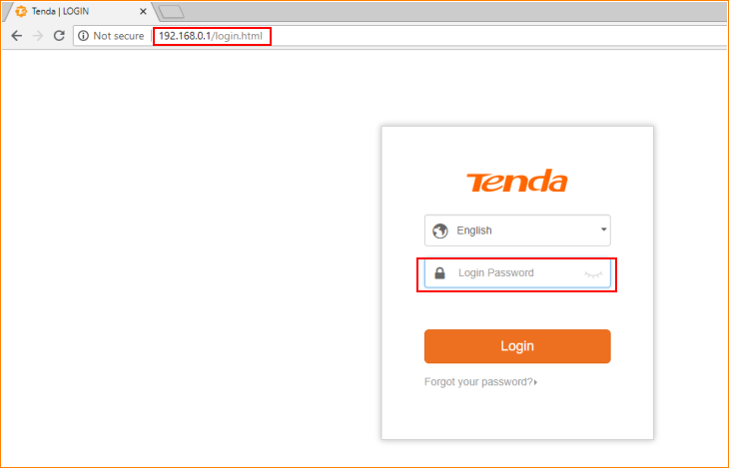

Note: The default password is shown on the bottom of the router. If you have changed it and you also forgot it, see “Forget your password?” below the “Login” button.

- Then the interface will turn into the homepage, type “Wireless Repeating”, you can see “Universal Repeater” option in this page.

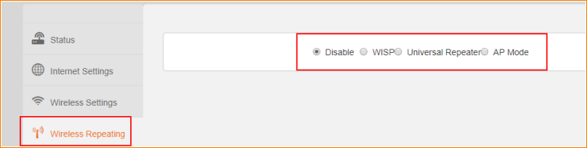

Step 2: Setup Universal Repeater

- Tap “Universal Repeater”, select your uplink WiFi signal, type its password, and tap “OK” to save all the settings.

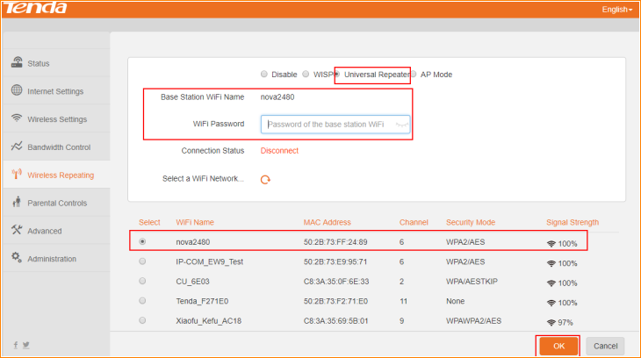

- Tap “OK” on the pop window, then the router will reboot automatically.

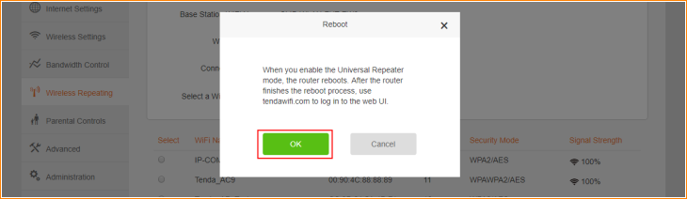

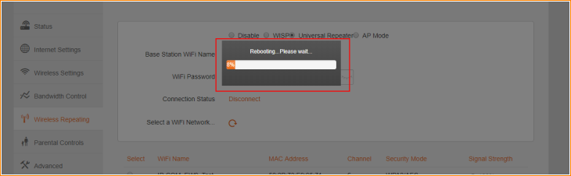

- After rebooting, login the homepage again, and tap “Status” to check the Connection Status of router. If the Connection Status is shown as below, that means you setup Universal Repeater successfully.

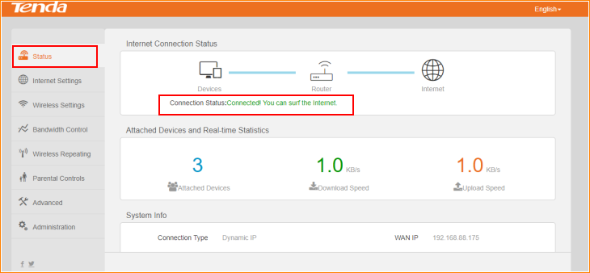

Note: In Universal Repeater, the DHCP server of this router will be disabled, the device connected with this router will get IP address from the uplink router.

